**ESE 499 Capstone Design Project Interim Progress Report**

**Submitted to Professors Trobaugh and Schaettler and the Department of Electrical and Systems Engineering**

**Vedant Jaipuria, Department of Systems Engineering, Bachelor of Science, vedant.jaipuria@wustl.edu**

**Sam Kramer, Department of Systems Engineering, Bachelor of Science, samdkramer@wustl.edu**

**Claudia Smith, Department of Systems Engineering, Bachelor of Science, claudiasmith@wustl.edu**

**Zachary Feinstein, Assistant Professor School of Engineering and Applied Science, Faculty Advisor, zfeinstein@wustl.edu**

**December 11, 2018**

**Title:**

**Maintenance of Firms’ Essential Capital Ratios with the Correct Liquidation Strategy**

**September 2018-December 2018**

**Abstract**

Over time, large scale financial systems made up of firms with common interests and investments become a tangled network of shared assets and overlapping portfolios. Although an investment strategy of diversified assets often is associated with financial security and reduced risk of loss, this strategy inevitably causes the investing firms to be increasingly dependent on one another. More specifically, these firms become much more dependent on the success and/or failure of one another, as a failing firm drives the market value prices of assets shared by other firms down. This negative price impact then causes the stability of other firms to be negatively impacted as well.

Within this project, we created a model that displayed the phenomenon of price impact and interdependent firms. Specifically, firms selling assets at a calculated proportion will result in capital ratios (total capital divided by illiquid assets) being maintained at a given threshold value. Then, we used this model to test the effects of varying portfolio degrees of diversification on the final stability of the system. Using these results, we were able to provide insight into the portfolio diversification measurements that provide the most stability for a financial network.

**Introduction**

In the current banking financial system there exists a legal regulation that all banks must ensure a capital ratio above the Basel III determined minimum threshold of 8%. The Basel III capital ratio requirement is a measure of a bank’s capital and risk weighted assets. It is important to maintain a capital ratio of 8% as it allows banks to remain liquid in the instance of a crisis, instead of becoming insolvent as they attempt to meet their financial obligation with their lenders [4]. If banks do not operate at a capital ratio of 8% or higher they are required to sell assets, which can lead to a feedback effect that results in many banks failing like the 2007-2009 crisis [2]. In our project we studied and modelled a financial network of multiple banks and assets in order to track and analyze their capital ratio as a function of time.

In order to accurately create a model of the different bank’s capital ratios we reviewed and extended upon Feinstein's known single asset and multiple bank model of the capital regulation under price-impacts and dynamic financial contagion [2]. The current model iteratively assesses the capital ratios of all banks within a financial network and sells a proportion of the banks’ assets whose capital ratios drop below 8%. The decision to sell assets is made in an attempt to raise capital, and it is made under the assumption that increasing capital buy selling new stock is unlikely after common shock [4]. A key principle to the single-asset, multi-bank model is that selling units of an asset diminishes that asset’s market value, thus depreciating the capital of all banks who own shares of that asset. This indirect contagion leads to a domino effect of banks making fire-sales and an increased number of firms’ capitals depreciating [2][4]. However, if we only examine the single assets multiple bank model we cannot gain insight into a banks diversification of assets portfolios. This is because in reality all banks hold more than one asset, thus a proportion of each asset is sold in order to satisfy the capital ratio requirement. Thus, we have created a model that uses parameters such as asset value and investment to produce a liquidation strategy that ultimately drive a bank’s capital ratio to 8%. To do so, we first developed a mathematical model of the capital ratio for banks within a multi-bank, multi-asset domain. From this model, we then determined the proportion at which banks should sell their assets during a crisis. We used this model to carry out the final deliverables of our project.

Specifically, our team aims to identify whether multiple shared assets among firms increases the stability of the system after common shock by decreasing the number of firms impacted by financial contagion of a single asset. Extending this concept further, we identified the difference between diversification and diversity of assets within a financial system. Namely, we analyzed the effect that varying portfolios of asset diversification and diversity have on the financial stability within our model. The stability of financial networks was measured by analyzing the final price impact of each asset, the total units of assets sold, and the total number of firms partaking in fire sales. Additionally, we identified a stress test for Greece’s 2011 financial systems. Drawing from the results of our models different tests, we provided insight into any strategic financial decisions, including rebalancing portfolios and increasing asset diversity or diversification, that might be taken by firms to prevent common shock within a financial network.

**Methods**

The key components to the analysis of our model when applied to financial networks are the final assets’ market value, the amount of assets sold by individual firms, and the capital ratio of each firm. These three components are essential to the understanding of the stability of the financial system and to the prediction of bank behavior during a crisis. More specifically, the capital ratio dictates when a firm must commit fire sales and liquidate its assets, leading to the depreciation of those assets’ prices. Thus, the stability of financial systems is directly impacted by firm’s capital ratios dropping below the minimum threshold. Additionally, the stability of the system can be measured by the final depreciation of asset prices (caused by fire sales) and the amount of assets each firm has liquidated. Below are the methods used to calculate the values of these key components within our model.

Multi-Bank, Single Asset Model:

Within the known model of a multi-bank, single asset financial network [2], the capital ratio is defined to be a firm’s capital over its risk-weighted illiquid assets. The following is used to derive firm $j$’s capital ratio value at any point in time within the multi-bank, single asset model:

*Equation 1:* Capital Ratio, ${θ_{}}_{j }(t)$ = $\frac{[x_{j }+Ψ_{j}(t)+(s_{j}-Γ_{j}(t))q(t){)-p_{j}]}^{+}}{α_{}(s_{j}-Γ_{j}(t))q(t)}$

Where,

$x$ = the bank’s liquid investments

$s$ = the bank’s initial units of illiquid investments

$p$ = the bank’s liabilities

$r(t)$ = the selling ratio of the bank

$q(t)$ = the price of each asset

$Γ(t)$ = the total units of assets liquidated

$ψ(t)$ = the total cash earned from liquidated assets

$α$ = the bank’s risk weight value (1 for all banks)

$t$ = the current unit of time within a discrete time frame

Throughout the multi-bank, single asset model’s simulation, the current price of the asset, $q(t)$, is calculated using the sum of all banks’ current units sold of that asset (or all banks’ $Γ(t)$ values). Below is the equation used to update the asset’s market value price:

*Equation 2: $q_{}(t) = e^{-t}e^{-b_{}\sum_{j= 0}^{j=m}{}Γ_{j}(t)}$*

Where,

$b$ = asset’s price impact value

$m$ = total number of banks

From Equation 2, it is relevant to note that $q(t)$ is defined as an exponential decay, because it is modelling a specific time frame within an economic crisis in which the market, and the prices of all illiquid assets, are dropping.

Furthermore, in the original model of the multi-bank, single-asset financial network, the number of assets sold during a fire sale is calculated directly. Once the firm’s capital ratio drops below the minimum threshold, the derivative of the capital ratio is set equal to 0, and the bank’s total units of assets needed to be liquidated in order to maintain the minimum threshold requirement, $Γ(t)$, is isolated and solved for. Then, the cash gained from this liquidation of assets is calculated by multiplying the number of assets sold and the price of those assets together. Below are the equations used to derive these values:

*Equation 3: $Γ_{j}(t) = Γ_{j}(t-1) -$ $\frac{z(-e^{-t}e^{-bΓ_{j}(t-1)})}{1+(ze^{-t}e^{-bΓ_{j}(t-1)})}$ $Δt$*

*Equation 4: $Ψ_{j}(t) = Γ_{j}(t)×q(t)$*

Where,

$Δt$ = 0.001

$z$*= $\frac{(-x_{j}+p_{j}-Ψ_{j}(t-1))(s_{j}-Γ_{j}(t-1))}{q_{j}(t-1)(q_{j}(t-1)(s_{j}-Γ_{j}(t-1))+Ψ_{j}(t-1)+x_{j}-p_{j}}$*

Multi-Bank, Multi-Asset Model:

When we adjusted the known model to incorporate firms’ ownership of multiple assets, the model changed in several ways. First, each bank’s $Γ(t)$, $Ψ(t)$, and $q(t)$ became vector values to allow ownership of multiple assets. As a result, the capital ratio was modified to include summations of these values over the total number of assets owned. Second, a selling ratio, $r(t)$, was introduced into the model. The selling ratio impacted the definition of both the capital ratio and $Γ(t)$. Below are the updated expressions used within the multi-bank, multi-asset model:

*Equation 5: ${θ_{}}_{j }(t)$*  = $\frac{[ x_{j } +\sum_{i= 0}^{i= n}{}Ψ_{ij}(t) +\sum_{i= 0}^{i= n}{}[s_{ij }(1-r_{j}(t))q_{i}(t){] - p_{j} ]}^{+}}{α_{}\sum_{i=0}^{i= n}{}[s_{i j}(1-r_{j}(t))q_{i}(t)]}$

*Equation 6: $q_{i}(t) = e^{-t}e^{-b_{}\sum_{j= 0}^{j=m}{}Γ_{ij}(t)}$*

*Equation 7: ${Γ_{}}_{ij}(t) = {s_{ij}}_{}×r_{j} (t)$*

*Equation 8: ${Ψ_{ij}}_{}(t) = {Γ_{ij}}_{}(t)×{q_{i}}_{}(t)$*

Where,

$n$ = total number of assets

For simplification purposes, $α$ was set to 1 for all banks. Additionally, $b$ is set to be 0.04 for all assets in the revised model. This is due to the model’s assumption that all assets are sold at the same proportion in a financial crisis. Assets having identical price impact values reestablishes this assumption.

The selling ratio is calculated with each occurance of a bank’s capital ratio dropping below the minimum threshold. In our model, we assume that each bank sells their asset portfolio at the same proportion, thus they use the selling ratio to update all of their assets. With each occurance of a bank’s capital ratio dropping below the threshold, we set Equation 5 equal to the minimum threshold and isolate and solve for ${r_{}}_{j }(t)$. Below is the derived expression for ${r_{ }}_{j }(t)$:

*Equation 9: ${{ r}_{}}_{j }(t)$ $= \frac{x_{j} - p_{j} + \sum_{i= 0}^{i= n}{}Ψ_{ij}(t) }{\sum_{i=0}^{i= n}{}{[s}_{ij}q_{i}(t)(θ_{min}α - 1)]}$*

Banks within the model use this new selling ratio to dictate the number of assets it should sell in each iteration. The banks will continue to sell assets at this proportion until their capital ratios drop below the threshold again, and $r_{ }(t)$ is recalculated.

The flowchart below shows the decisions and calculations that our model takes to maintain firms’ essential capital ratios. In short, all bank’s $Γ(t)$ values are calculated using their initial illiquid asset, or stock, holdings and their current selling ratio. All banks start with an initial selling ratio of 0. Then, these $Γ(t)$ values are used in the calculations of the illiquid assets’ market value prices. These prices are then fed into the calculations of firms’ capital ratios. At this point, the firms’ capital ratios are checked against the minimum threshold of 0.08, and firms whose capital ratios are below the threshold are forced to recalculate their selling ratio and begin selling their illiquid assets at this new proportion. Else, firms continue to sell their assets at the previous selling ratio proportion. The flowchart highlights the indirect contagion among firms, as the stability of one firm impacts the stability of others. More specifically, as unstable firms commit fire sales, the prices of illiquid assets are driven down, and *all* firms who also hold these assets are negatively impacted.

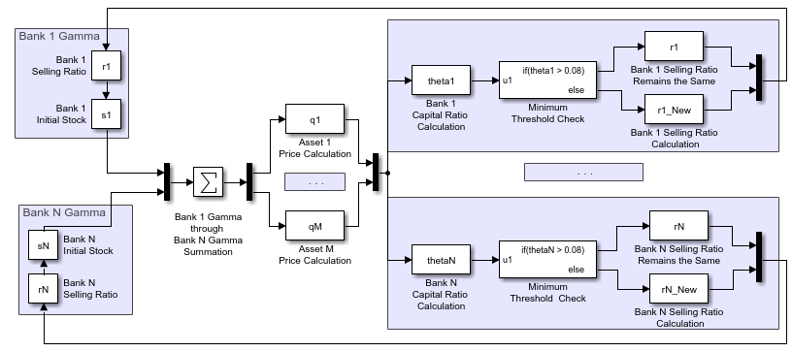

*Figure 1: The flowchart of our model’s logic in maintaining firms’ essential capital ratios.*

The model depicted in Figure 2 is a simplified representation of the financial networks we are modelling. Specifically, this is a representation of a financial network made up of both multiple banks and multiple assets. Furthermore, there is some degree of diversificationin the network such that some banks own multiple assets, and some assets are owned by multiple banks. We calculated the diversification of the financial network within our model, and analyzed the potential relationship between the stability of the banking network and amount of diversification among portfolios.

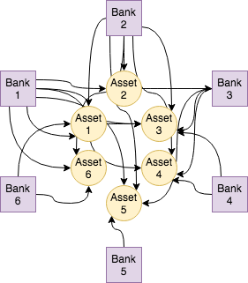

*Figure 2: A representation of a modeled financial network. The circles represent assets; the squares represent banks. The lines connecting the two show ownership. In this network some banks share all 6 assets like Bank 1 and Bank 2 and some banks share no assets like Bank 5 and 6.*

In order to analyze the financial network’s asset diversification we performed multiple stress tests with different degrees of diversification. It is important to note that the degree of diversification is a percentage that we calculated and is not a universal method to calculate the degree diversification, rather specific to our model. To calculate the degree of diversification for each asset in our model we first found the average median ownership of each asset shown in Equation 10. Next we found the diversification “error” by taking the difference in the average sum of each asset’s median and 16.67. We use 16.67 because this represents the ownership proportion of an asset held equally by all 6 banks in the network. After finding the error, we divided by 16.67 and multiplied by 100 to find the degree of asset diversification shown in Equation 11.

*Equation 10: $AvgM=\frac{\sum_{i =1}^{m}{}{Med}_{i}}{m}$*

*Equation 11:* Degree of Asset Diversification $, D = \frac{\left|AvgM-16.67^{*}\right|}{16.67^{*}}×100$

Where,

${Med}_{i}$*is equal to the median of asset i*

*m is equal to the number of assets in the network*

16.67* is specific to our financial network with 6 banks and 6 models

We performed our stress test with 5 different degrees of diversification. The highest degree possible is 100, which represents the scenario of complete asset diversity. In complete asset diversity each individual bank only owns 1 asset and has 100% ownership over this asset. The lowest degree of diversification is 0, which represents the scenario of complete diversification where every individual bank owns all assets and have equal ownership of each individual asset. Any degree between 0 and 100 represents a portfolio of asset diversification that are neither completely diverse nor completely diversified. Instead, these portfolios hold certain degree of asset diversification, $D,$ that corresponds to varying ownership and asset distribution. In our stress tests, we tested complete diversity, complete diversification, and 4 random degrees of asset diversification. The models of the different degrees of diversification can be seen in the results section.

**Data Collection**

In order to test our model with real world data, we initialized our algorithm with the financial data of the banks’ balance sheets from the European Banking Authority 2011 EU-wide stress test [6]. We performed different stress tests by using the total risk weighted assets and capital composition of 6 different banks from the 2011 Greek banking system. Each of the banks risk weighted assets represent one of the six assets values and the capital composition of each bank equals that banks cash. In order to have values that fit our model we had to scale the risk weighted assets and capital composition by 8.

**Results**

A six-bank, six-asset model was used to perform stress tests on the Greece financial network. The system was tested at differing degrees of portfolio diversity. The corresponding results at differing portfolio diversity levels are shown in the following section.

**Complete Portfolio Diversity, $D=100$:**

Below are the stress test results when the simulated Greece portfolio had complete diversity. That is, each firm within the model owned a single asset independently. These asset ownership values were derived and scaled from the banks’ balance sheets from the European Banking Authority 2011 EU-wide stress test. More specifically, each bank’s balance-sheet value for owned illiquid assets was scaled and implemented into our model.

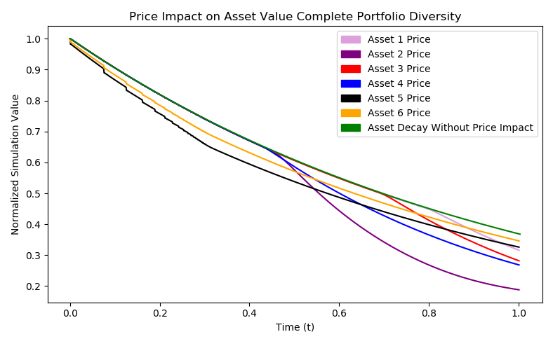

*Figure 3: Price impact of Greece asset values with complete portfolio diversity.*

Total Number of Firms Committing Fire Sales: 6

|  |  |  |  |  |  |
| --- | --- | --- | --- | --- | --- |
| Final Price Depreciation Asset 1 | Final Price Depreciation Asset 2 | Final Price Depreciation Asset 3 | Final Price Depreciation Asset 4 | Final Price Depreciation Asset 5 | Final Price Depreciation Asset 6 |
| 0.0520 | 0.1800 | 0.0862 | 0.0995 | 0.0419 | 0.0217 |

*Table 1: Final asset price depreciation values owned by banks within the Greece stress test with complete portfolio diversity. The price depreciation is calculated as the final asset’s price difference from the asset decay with no price impact.*

|  |  |  |  |  |  |  |
| --- | --- | --- | --- | --- | --- | --- |
| Bank  # | Percent of Asset 1 Sold  (%) | Percent of Asset 2 Sold  (%) | Percent of Asset 3 Sold  (%) | Percent of Asset 4 Sold  (%) | Percent of Asset 5 Sold  (%) | Percent of Asset 6 Sold  (%) |
| 1 | 31.6 | N/A | N/A | N/A | N/A | N/A |
| 2 | N/A | 98.7 | N/A | N/A | N/A | N/A |
| 3 | N/A | N/A | 51.2 | N/A | N/A | N/A |
| 4 | N/A | N/A | N/A | 78.6 | N/A | N/A |
| 5 | N/A | N/A | N/A | N/A | 100 | N/A |
| 6 | N/A | N/A | N/A | N/A | N/A | 100 |

*Table 2: Percentage of assets sold owned by banks within the Greece stress test with complete portfolio diversity.*

**Complete Portfolio Diversification, $D$ = 0:**

Below are the stress test results when the simulated Greece portfolio had complete diversification. That is, each firm within the model owned equal shares of all assets. These asset ownership values were derived by dividing the asset values used in the complete diversity portfolio by 6, i.e. by the total number of banks.

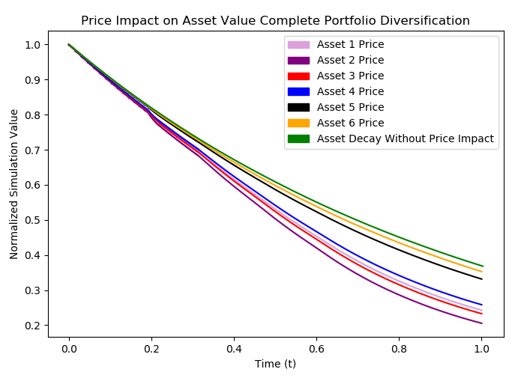

*Figure 4: Price impact of Greece asset values with complete portfolio diversification.*

Total Number of Firms Committing Fire Sales: 6

|  |  |  |  |  |  |
| --- | --- | --- | --- | --- | --- |
| Final Price Depreciation Asset 1 | Final Price Depreciation Asset 2 | Final Price Depreciation Asset 3 | Final Price Depreciation Asset 4 | Final Price Depreciation Asset 5 | Final Price Depreciation Asset 6 |
| 0.126 | 0.163 | 0.135 | 0.110 | 0.037 | 0.015 |

*Table 3: Final asset price depreciation values owned by banks within the Greece stress test with complete portfolio diversification. The price depreciation is calculated as the final asset’s price difference from the asset decay with no price impact.*

|  |  |  |  |  |  |  |
| --- | --- | --- | --- | --- | --- | --- |
| Bank  # | Percent of Asset 1 Sold  (%) | Percent of Asset 2 Sold  (%) | Percent of Asset 3 Sold  (%) | Percent of Asset 4 Sold  (%) | Percent of Asset 5 Sold  (%) | Percent of Asset 6 Sold  (%) |
| 1 | 78.5 | 78.5 | 78.5 | 78.5 | 78.5 | 78.5 |
| 2 | 99.9 | 99.9 | 99.9 | 99.9 | 99.9 | 99.9 |
| 3 | 91.9 | 91.9 | 91.9 | 91.9 | 91.9 | 91.9 |
| 4 | 91.9 | 91.9 | 91.9 | 91.9 | 91.9 | 91.9 |
| 5 | 98.4 | 98.4 | 98.4 | 98.4 | 98.4 | 98.4 |
| 6 | 59.2 | 59.2 | 59.2 | 59.2 | 59.2 | 59.2 |

*Table 4: Final units sold (or $Γ$ values) of assets owned by banks within the Greece stress test with complete portfolio diversification.*

**Varied Diversification Model 1, $D$*=* 81.04:**

Below are the stress test results when the simulated Greece portfolio had an asset diversification degree of 81.04.

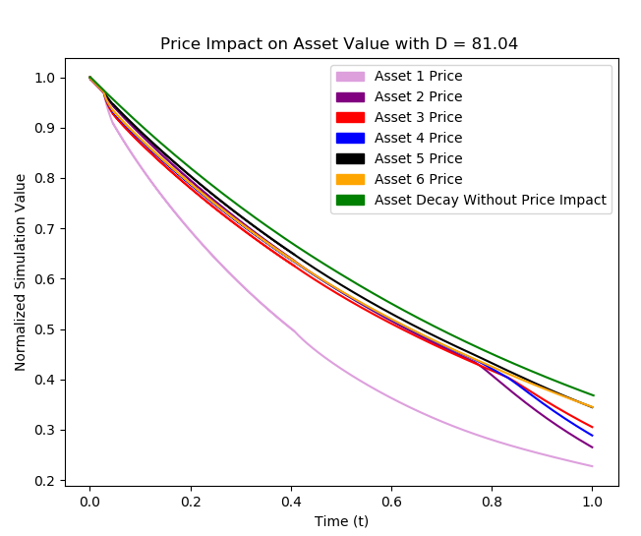

*Figure 5: Price impact of Greece asset values with portfolio asset diversification of degree 81.04.*

Total Number of Firms Committing Fire Sales: 6

|  |  |  |  |  |  |
| --- | --- | --- | --- | --- | --- |
| Final Price Depreciation Asset 1 | Final Price Depreciation Asset 2 | Final Price Depreciation Asset 3 | Final Price Depreciation Asset 4 | Final Price Depreciation Asset 5 | Final Price Depreciation Asset 6 |
| 0.1425 | 0.1077 | 0.0673 | 0.0845 | 0.0269 | 0.0260 |

*Table 5: Final asset price depreciation values owned by banks within the Greece stress test with portfolio asset diversification of degree 81.04. The price depreciation is calculated as the final asset’s price difference from the asset decay with no price impact.*

|  |  |  |  |  |  |  |
| --- | --- | --- | --- | --- | --- | --- |
| Bank  # | Percent of Asset 1 Sold  (%) | Percent of Asset 2 Sold  (%) | Percent of Asset 3 Sold  (%) | Percent of Asset 4 Sold  (%) | Percent of Asset 5 Sold  (%) | Percent of Asset 6 Sold  (%) |
| 1 | 100 | 100 | 100 | 100 | 100 | 100 |
| 2 | 46.10 | 46.10 | 46.10 | 46.10 | 46.10 | 46.10 |
| 3 | 100 | 100 | 100 | 100 | 100 | 100 |
| 4 | 3.35 | 3.35 | 3.35 | 3.35 | 3.35 | 3.35 |
| 5 | 2.31 | 2.31 | 2.31 | 2.31 | 2.31 | 2.31 |
| 6 | 2.52 | 2.52 | 2.52 | 2.52 | 2.52 | 2.52 |

*Table 6: Percentage of assets sold owned by banks within the Greece stress test with portfolio asset diversification of degree 81.04.*

**Varied Diversification Model 2, $D$ = 53.09:**

Below are the stress test results when the simulated Greece portfolio had an asset diversification degree of 53.09.

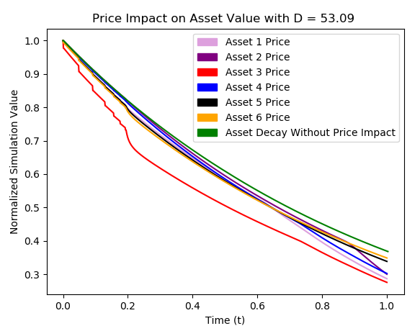

*Figure 6: Price impact of Greece asset values with portfolio asset diversification of degree 53.09.*

Total Number of Firms Committing Fire Sales: 6

|  |  |  |  |  |  |
| --- | --- | --- | --- | --- | --- |
| Final Price Depreciation Asset 1 | Final Price Depreciation Asset 2 | Final Price Depreciation Asset 3 | Final Price Depreciation Asset 4 | Final Price Depreciation Asset 5 | Final Price Depreciation Asset 6 |
| 0.0855 | 0.0741 | 0.2720 | 0.0699 | 0.0329 | 0.0226 |

*Table 7: Final asset price depreciation values owned by banks within the Greece stress test with portfolio asset diversification of degree 53.09. The price depreciation is calculated as the final asset’s price difference from the asset decay with no price impact.*

|  |  |  |  |  |  |  |
| --- | --- | --- | --- | --- | --- | --- |
| Bank  # | Percent of Asset 1 Sold  (%) | Percent of Asset 2 Sold  (%) | Percent of Asset 3 Sold  (%) | Percent of Asset 4 Sold  (%) | Percent of Asset 5 Sold  (%) | Percent of Asset 6 Sold  (%) |
| 1 | 2.89 | 2.89 | 2.89 | 2.89 | 2.89 | 2.89 |
| 2 | 100 | 100 | 100 | 100 | 100 | 100 |
| 3 | 2.14 | 2.14 | 2.14 | 2.14 | 2.14 | 2.14 |
| 4 | 2.76 | 2.76 | 2.76 | 2.76 | 2.76 | 2.76 |
| 5 | 100 | 100 | 100 | 100 | 100 | 100 |
| 6 | 8.62 | 8.62 | 8.62 | 8.62 | 8.62 | 8.62 |

*Table 8: Percentage of assets sold owned by banks within the Greece stress test with portfolio asset diversification of degree 53.09.*

**Varied Diversification Model 3, $D$ = 7.98:**

Below are the stress test results when the simulated Greece portfolio had asset diversification degree of 7.98.

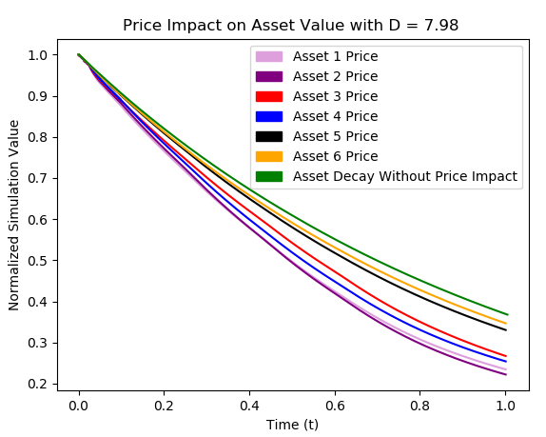

*Figure 7: Price impact of Greece asset values with portfolio asset diversification of degree 7.98.*

Total Number of Firms Committing Fire Sales: 6

|  |  |  |  |  |  |
| --- | --- | --- | --- | --- | --- |
| Final Price Depreciation Asset 1 | Final Price Depreciation Asset 2 | Final Price Depreciation Asset 3 | Final Price Depreciation Asset 4 | Final Price Depreciation Asset 5 | Final Price Depreciation Asset 6 |
| 0.1358 | 0.1483 | 0.1037 | 0.1164 | 0.0405 | 0.0243 |

*Table 9: Final asset price depreciation values owned by banks within the Greece stress test with portfolio asset diversification of degree 7.98. The price depreciation is calculated as the final asset’s price difference from the asset decay with no price impact.*

|  |  |  |  |  |  |  |
| --- | --- | --- | --- | --- | --- | --- |
| Bank  # | Percent of Asset 1 Sold  (%) | Percent of Asset 2 Sold  (%) | Percent of Asset 3 Sold  (%) | Percent of Asset 4 Sold  (%) | Percent of Asset 5 Sold  (%) | Percent of Asset 6 Sold  (%) |
| 1 | 4.37 | 4.37 | 4.37 | 4.37 | 4.37 | 4.37 |
| 2 | 61.87 | 61.87 | 61.87 | 61.87 | 61.87 | 61.87 |
| 3 | 10.96 | 10.96 | 10.96 | 10.96 | 10.96 | 10.96 |
| 4 | 37.63 | 37.63 | 37.63 | 37.63 | 37.63 | 37.63 |
| 5 | 24.79 | 24.79 | 24.79 | 24.79 | 24.79 | 24.79 |
| 6 | 2.39 | 2.39 | 2.39 | 2.39 | 2.39 | 2.39 |

*Table 10: Percentage of assets sold owned by banks within the Greece stress test with portfolio asset diversification of degree 7.98.*

**Discussion**

The results from the preliminary Greece stress test have been consistent with what we expected. Specifically, firms commiting fire sales have had their capital ratios driven to the minimum threshold, and these fire sales have led to the increased decline in both asset values and other bank’s capital ratios. The price impact of fire sales on assets’ market value prices is seen in Figure 3, Figure 4, Figure 5, Figure 6, and Figure 7. Once a bank begins to sell its assets, the price of those assets decreases, and the final assets’ prices are less than the final projected asset price. This projected asset price represents a system in which there are no fire sales within the network.

For our results, we used an incrementation step in our simulation, or a $Δt$ value, of 0.001. This value causes the most noticeable tradeoff within our model. The model runs from time 0 to time 1, with a change of $Δt$ in each iteration. So, $Δt$ essentially dictates the number of iterations our model undergoes. The more iterations our model has, the more linearized our system becomes, and the resulting graphs are more accurate and smooth. However, values of $Δt$ smaller than 0.001 can produce hour long runtimes. We found that 0.001 was the smallest value of $Δt$ we could use that still provided a reasonable runtime.

Further improvements for our model include developing another model that produces the selling ratio by a different method. Because there are no other existing multi-bank, multi-asset models of capital regulation under price-impacts and dynamic financial contagion, producing this additional model would increase the reliability of our results. Steps to create this new model include setting the derivative of Equation 9 equal to zero and solving for $Δr$. Once $Δr$ has been calculated, $r(t)$ be updated each iteration by adding $Δr$ to its existing value. This new method of solving for the selling ratio would replace Equation 10 within the model. Furthermore, the remainder of the new model would be the same as our own.

Another improvement that we can make to our model is in defining the degree of asset diversification. Since there is no known universal method to calculate a bank’s asset diversification, we developed our own algorithm. However, with more time we believe that it would have been possible to develop a more robust and correct degree of diversification equation that would not only be specific to a 6-bank, 6-asset financial network.

**Conclusion-**

|  |  |  |  |
| --- | --- | --- | --- |
| Model Degree | Average Price Depreciation Among Assets | Average Percent of Assets Sold Among Firms(%) | Total Number of Firms Committing Fire Sales |
| 0 | 0.0980 | 76.77 | 6 |
| 7.98 | 0.0949 | 23.69 | 6 |
| 53.09 | 0.0928 | 36.07 | 6 |
| 60.08 | 0.0931 | 28.56 | 6 |
| 70.56 | 0.0576 | 36.56 | 5 |
| 75.05 | 0.0607 | 36.12 | 5 |
| 81.04 | 0.0758 | 42.38 | 6 |
| 100 | 0.0802 | 76.68 | 6 |

*Table 11: Final values of the average asset price impact, average percentage of assets sold, and total number of firms committing fire sales for models with varying degrees of asset diversification.*

From the data above, one can see that financial systems with degrees’ of diversification near the range of 70 and 75 appear to be the most stable, defining a stable system by relatively low average asset price depreciation and low average percent of assets sold. Although models with degrees in the range of 70 and 75 did not have the *lowest* average percent of assets sold, these values were significantly low relative to the various system models. In a real crisis situation, similar to the one modeled, a bank would be forced to liquidate assets to remain solvent, and the costs incurred by the actual asset sales should not be overlooked. These, often multi-million dollar, transactions require additional investment in both personnel and administrative costs. Thus, a bank that sells a relatively low percentage of its asset holding will most likely bear a far more manageable financial burden. Also, a low percent of assets sold, *within a given time period*, reflects a system of banks that are in an overall less panicked situation, as they can liquidate their assets a slower rate. A bank allowed more time to liquidate their assets will likely make more effective and calculated decisions. This opportunity for more precise decision making can be crucial when dealing with such high volume asset portfolios.

Furthermore, the models in the range of 70 and 75 consistently resulted in the lowest average asset price depreciation and the fewest number of failing firms. A lower price depreciation among the assets in the network results in an overall higher value of capital among all banks in the network. In a financial system that represents a national network of banks, like the Greek system we modeled, a higher overall asset value reflects the stability and desirability of the given nation’s economy. If less firms within a network commit fire sales in a crisis situation, there are a higher number of stable firms within the network and, thus, a more overall stable network (based on the metrics discussed above). Finally, we can note that systems that are either completely diverse or completely diversified produce the least stable results.

**Deliverables**

Specifically, we have delivered a n-bank, m-asset model of capital regulation under price impacts and dynamic financial contagion. We have conducted stress tests on the 2011 Greece financial network with varied portfolio diversifications. We have provided insight into how varying diversification and diversity within the network affects the stability of the system. We have also provided a well-written final report on our findings and a corresponding informational webpage.

**Schedule**

Gantt Chart

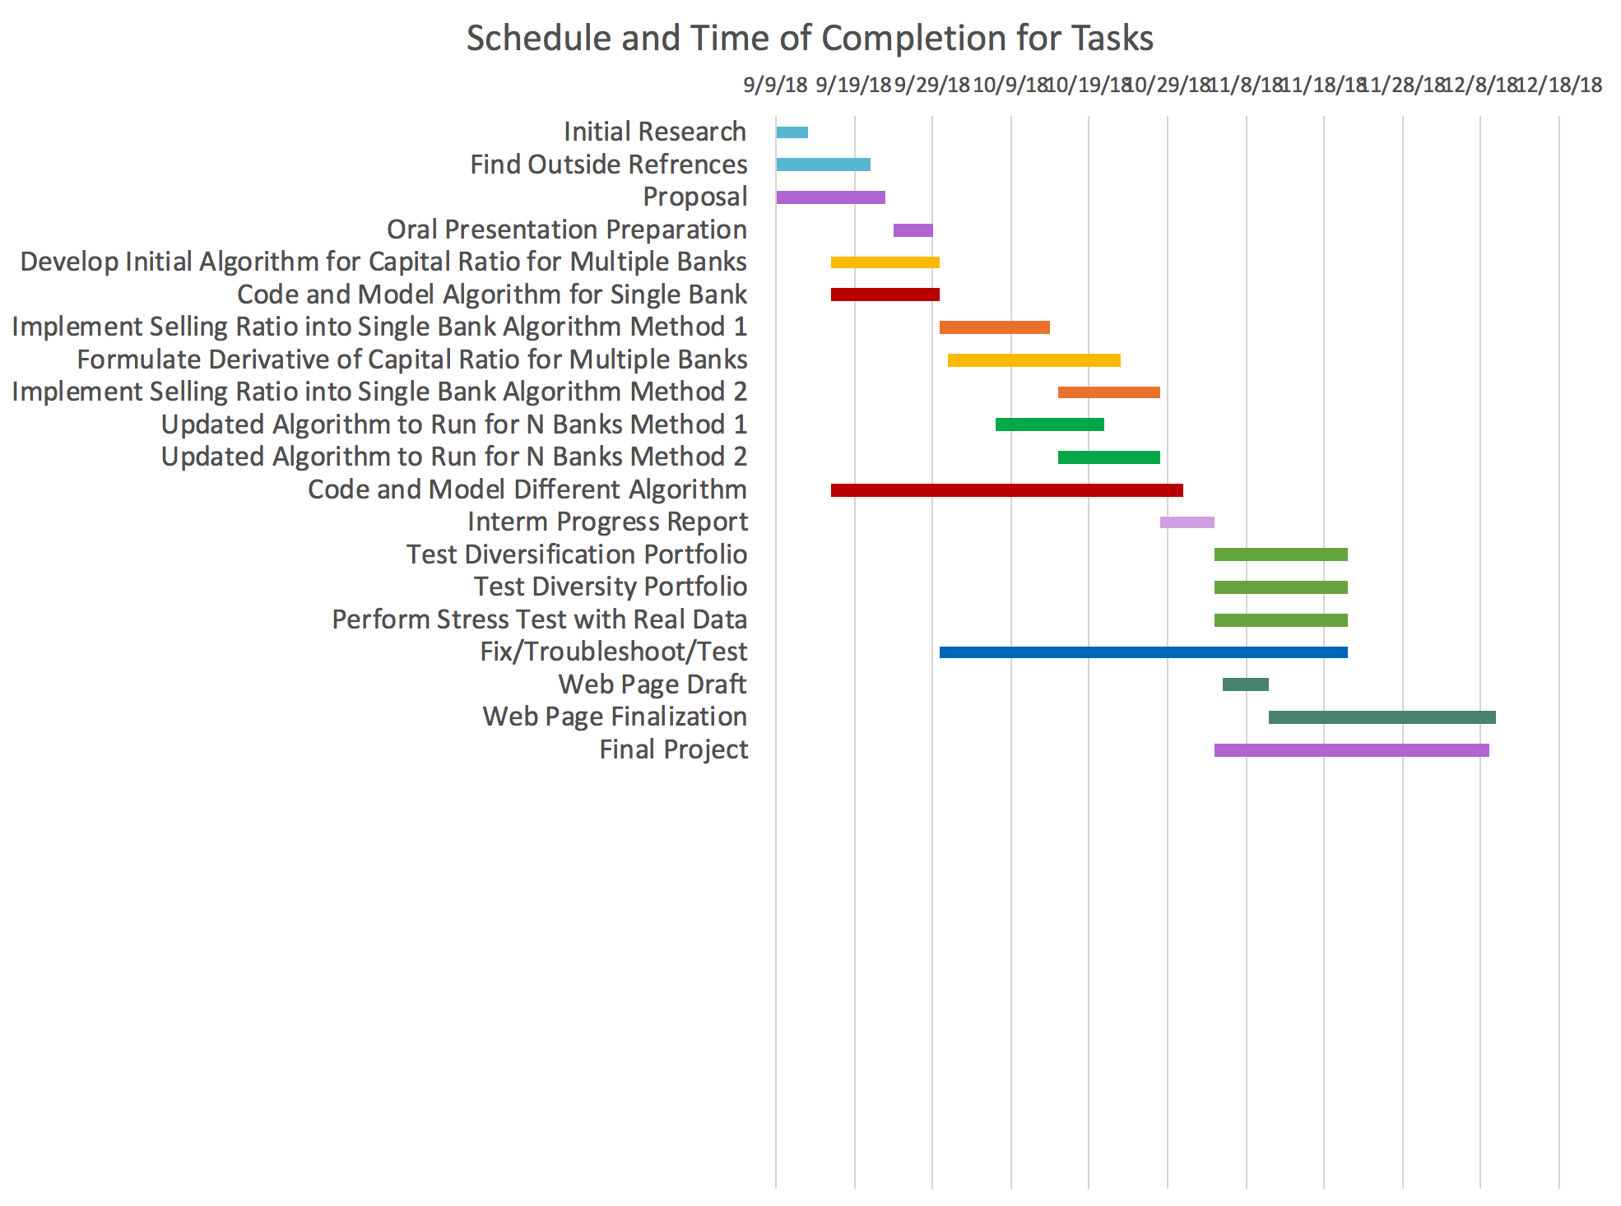

In respect to our Gantt Chart from the Project Updated document we adhered to progress almost perfectly. However, it did take us longer than expected to derive a degree of diversification equation in order to test the different degrees in our algorithm.

Claudia designed the single-bank, multi-asset model and the multi-bank, multi-asset model for this project. This included developing a 6-bank, 6-asset model that represented the 2011 Greece financial network. Claudia is a computer science minor and created the original multi-bank, single-asset model on which our current project is based. She also studied this topic with Professor Feinstein in undergraduate research last semester.

Vedant concentrated on developing the updated capital ratio equation and the selling ratio equation used within our model. He also analyzed the European Banking Authority 2011 EU-wide stress test data and derived the scaled initial balance-sheet values used within our project’s stress test. Vedant’s second major is Financial Engineering and has taken Financial Mathematics. Vedant also has experience working in the financial industry for the last three summers, and, thus, he was able to provide our team with crucial context and perspective of the financial systems we are modeling.

Sam developed the logic used in varying the portfolio diversity within our model. Specifically, he developed an algorithm to provide initial asset ownership values for our model based on varying degrees of portfolio diversity. Pursuing a degree in systems engineering, Sam has experience in both computer science and mathematical modeling. Thus, he was able to use both of these skill sets to assist in the development of the theory behind the model, calculation process, and the final algorithm.

**References**

[1] Caccioli, Fabio, et al. “Stability Analysis of Financial Contagion Due to Overlapping Portfolios.” SSRN Electronic Journal, 2012.

[2] Feinstein, “Capital Regulation under Price Impacts and Dynamic Financial Contagion,” 2018.

[3] Rodrigo Cifuentes, Hyun Song Shin, and Gianluigi Ferrucci. “Liquidity Risk and Contagion”, Journal of the European Economic Association, 3(2-3):556–566, 2005.

[4] Y. Braouezec and L. Wagalath, “Strategic Fire-Sales and Price-Mediated Contagion in the Banking System,” SSRN Electronic Journal, 2017.

[5] Zachary Feinstein and Fatena El-Masri. “The Effects of Leverage Requirements and Fire Sales on Financial Contagion via Asset Liquidation Strategies in Financial Networks,” Statistics & Risk Modeling, 34(3-4):113–139, 2017.

[6] “2011 EU-Wide Stress Test Results.” *Liquidity Risk - European Banking Authority*, www.eba.europa.eu/risk-analysis-and-data/eu-wide-stress-testing/2011/results.